HCI Project 3

By Brian Nguyen, Woo-Jae Lee, and Cody Fulford

University of Calgary

CPSC 481 - HCI

# Affinity Diagram

To develop our affinity diagram, we first each drew some sketches for the user interface. We did these drawings individually so that we could bring the ideas together at the end and compare the ideas from different perspectives. Next we discussed the strengths and weaknesses of our sketches by going through them one by one. We took turns speaking about our sketches while the other group members took notes about the strengths and weaknesses of their idea. After that each group member had a list of important design concepts from the sketches. After enumerating these design concepts, we spread them across a table and grouped them up into separate categories. Initially we had eight different categories for our design concepts:

* Important application design concepts (usability, modularity)
* Skill hill information
* Ratings
* Ski hill services
* Restaurants
* Transportation
* Emergency Services
* Multiple languages support

Finally, we reduced and combined these categories into four categories:

* Skill hill information
* Services that the resort offers
* Application design (usability, modularity, ease of use)
* Transportation (location of resort, restaurants)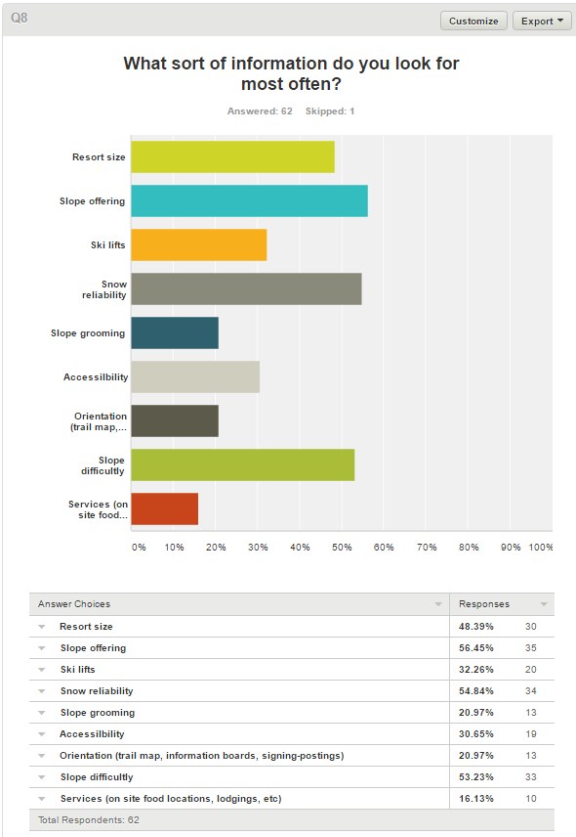

Per our survey results, we identified the major features that our stakeholders want to know about a resort. Our primary stakeholders are the people who are visiting the ski resorts for their leisure. Upon reflection of our sketches, we also produced similar results related to our survey. Weather, location, ski hill availability, and price were the major features that our application must have. These features are under the ski hill information category.

We also recognized that if our users are on the go on the skill hill, then they would be wearing gloves. An ideal app for our users would include buttons that are large enough so that they would be able press the buttons that they want. We also thought that a minimalistic design is ideal, perhaps a main menu that includes only the essential things. These concepts were included under the application design category.

We noticed that we had several concepts related to transportation. In P1, we determined that stakeholders such as travel agents would want to track several hundred resorts at the same time and make informed decisions for their clients. They would require transportation information as well as users who are skiing for just their leisure. We grouped together the following ideas under this category: resort location, restaurant location, distance, and map of resort. These concepts are related to the problem where given point A, how do I arrive at point B.

Finally, the last category is the services that a resort can offer. This category is related to the group of stakeholders comprised of resort owners and resort workers. Resort owners would want to showcase the accommodations that they can offer as well as emergency services and contact information. Potential resort workers would be interested in the contact information of say a restaurant so they could apply. Current resort workers such as ski patrols would use an overview map to get to somewhere if they did not have a map on hand. Coincidentally, some of the ideas that we came up with were emergency services, lost and found information, rental and restaurants information which all fall under this category and relate to these group of stakeholders.

# Polished Versions

We have chosen these three designs as the most promising for satisfying our customer’s needs. The main need for our users is ease of use. This is because our users will often be in a hurry to find the information that they need, or on a ski hill where they will be, for all intents, disabled. While our customers will not actually be disabled, it is important to think of them as such because of the gloves that many skiers wear. These gloves greatly increase the size of their fingers and reduce the responsiveness of the touchscreen. Even the gloves that are specially designed to work with touchscreens increases the size of the finger. Should the customers gloves not work with the touchscreen, it is possible that they will remove the gloves to use the application. This means that the users hags will most likely be cold and shaking. These limitations that the customer will probably have sound very like what we would have to design for older people. We can also assume that the customers will be using the application with both hands since they will be standing over the snow. We assume that the customer will hold the phone with one hand and use it with the other. If the customer leaves their glove on the hand that is holding the phone, the extra bulk of their gloves will cover some portions of the screen. The area that the gloves can cover will mostly be the middle of the vertical portion of the screen, extending towards the middle of the screen. These problems have pushed us towards design concepts that emphasize speed and ease of use. All our designs use large buttons to allow people with large finders and shaky hands to easily navigate our application.

The first sketch that you can see shows how we can arrange the screen showing information about a specific ski resort in a design that accommodates both speed and ease of use for those who are wearing gloves. It accomplishes this by having large buttons that extend into the middle of the window, this allows the customer to press the buttons even while their hands are shaking or they are wearing large gloves. The other aspect that this design exemplifies is speed. If the customer is not using our application, they are not currently skiing. Since the customer is wanting to ski more than use our application, having the information for a specific ski hill be hidden behind several menus would drive customers away as threw would get frustrated with our application. What we have designed to accommodate this need is that we have placed all the information that our studies in project 1 identified as most important directly on the front page of the individual ski resort page. This means that the current weather conditions, number of open lifts, and hill rating are displayed the moment that the user opens the specific ski resorts web page. This design worked to combine both concepts of ease of use and information display.

Thee second design that we decided was most promising focuses on the design aspect of large buttons. As you can see from the sketch, the buttons that we would be using are so large it only takes a few of them to fill a screen. While this design for the hotels does not have nearly as much information concentration as the first design concept, it can be used in a slower more deliberate way. What we mean by this is that the user will be less likely to make mistakes when the buttons are as large as they are at the expense of the customer being required to tap more buttons to get to some less critical information. What this design also allows though is more high level information such as photos, or distance to a hotel. This sort of information stands out since there is less information concentration and allows the client to quickly sift through potential options. Since there is less information to sort through, it is possible that this will increase the speed that the customer can use the application.

The third sketch that we have decided has high potential supports our design concepts of low clutter and high speed of information. Since there are so few buttons on the screen, it allows the user to focus on the information on the screen while removing the possibility of a mistake. Having most the information on the screen all at one time allows a user to quickly read through it and absorb the information without needing to scroll which can lead to mistakes.

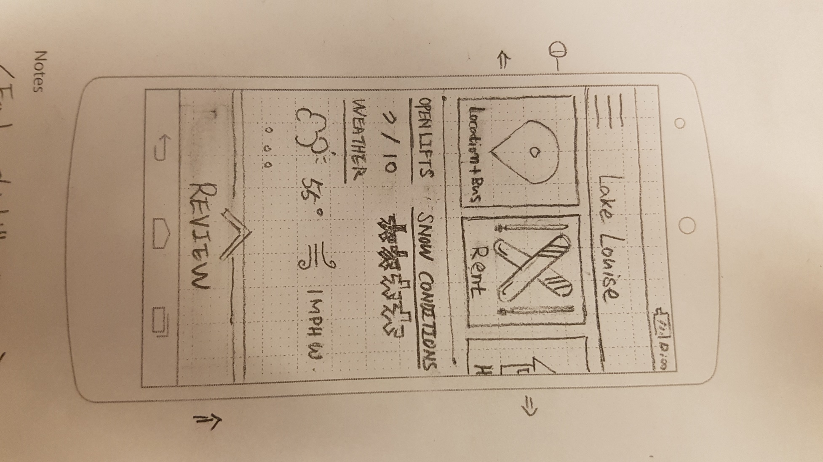

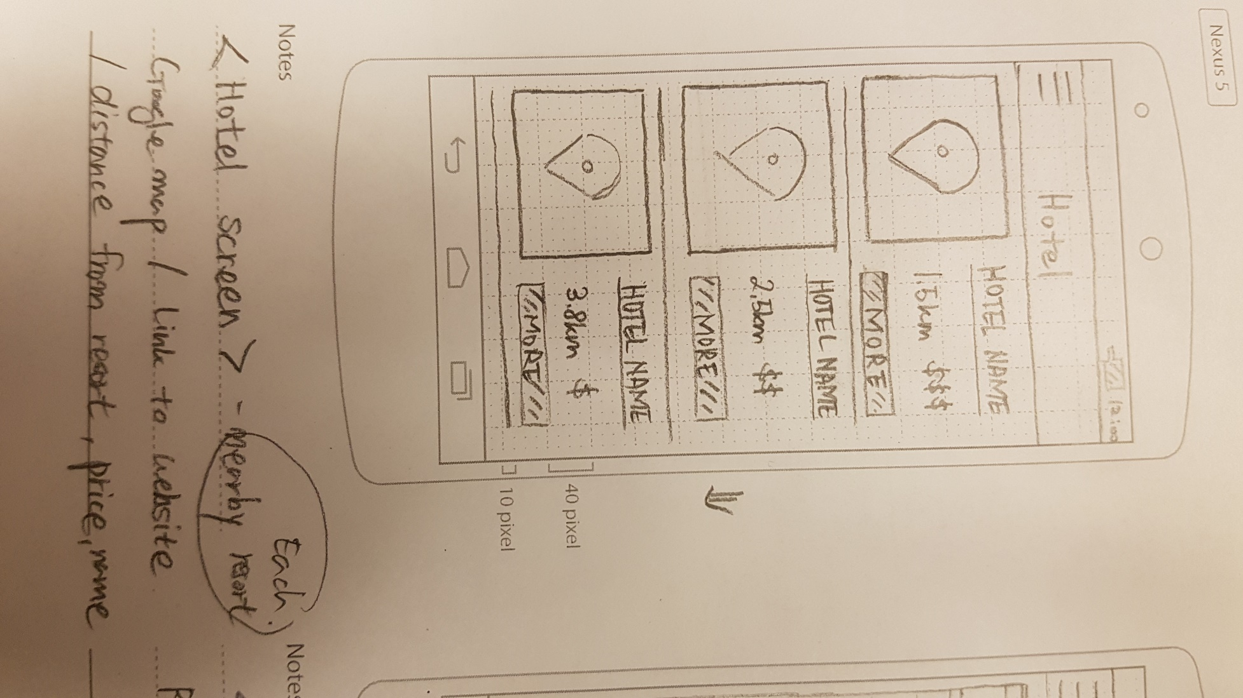

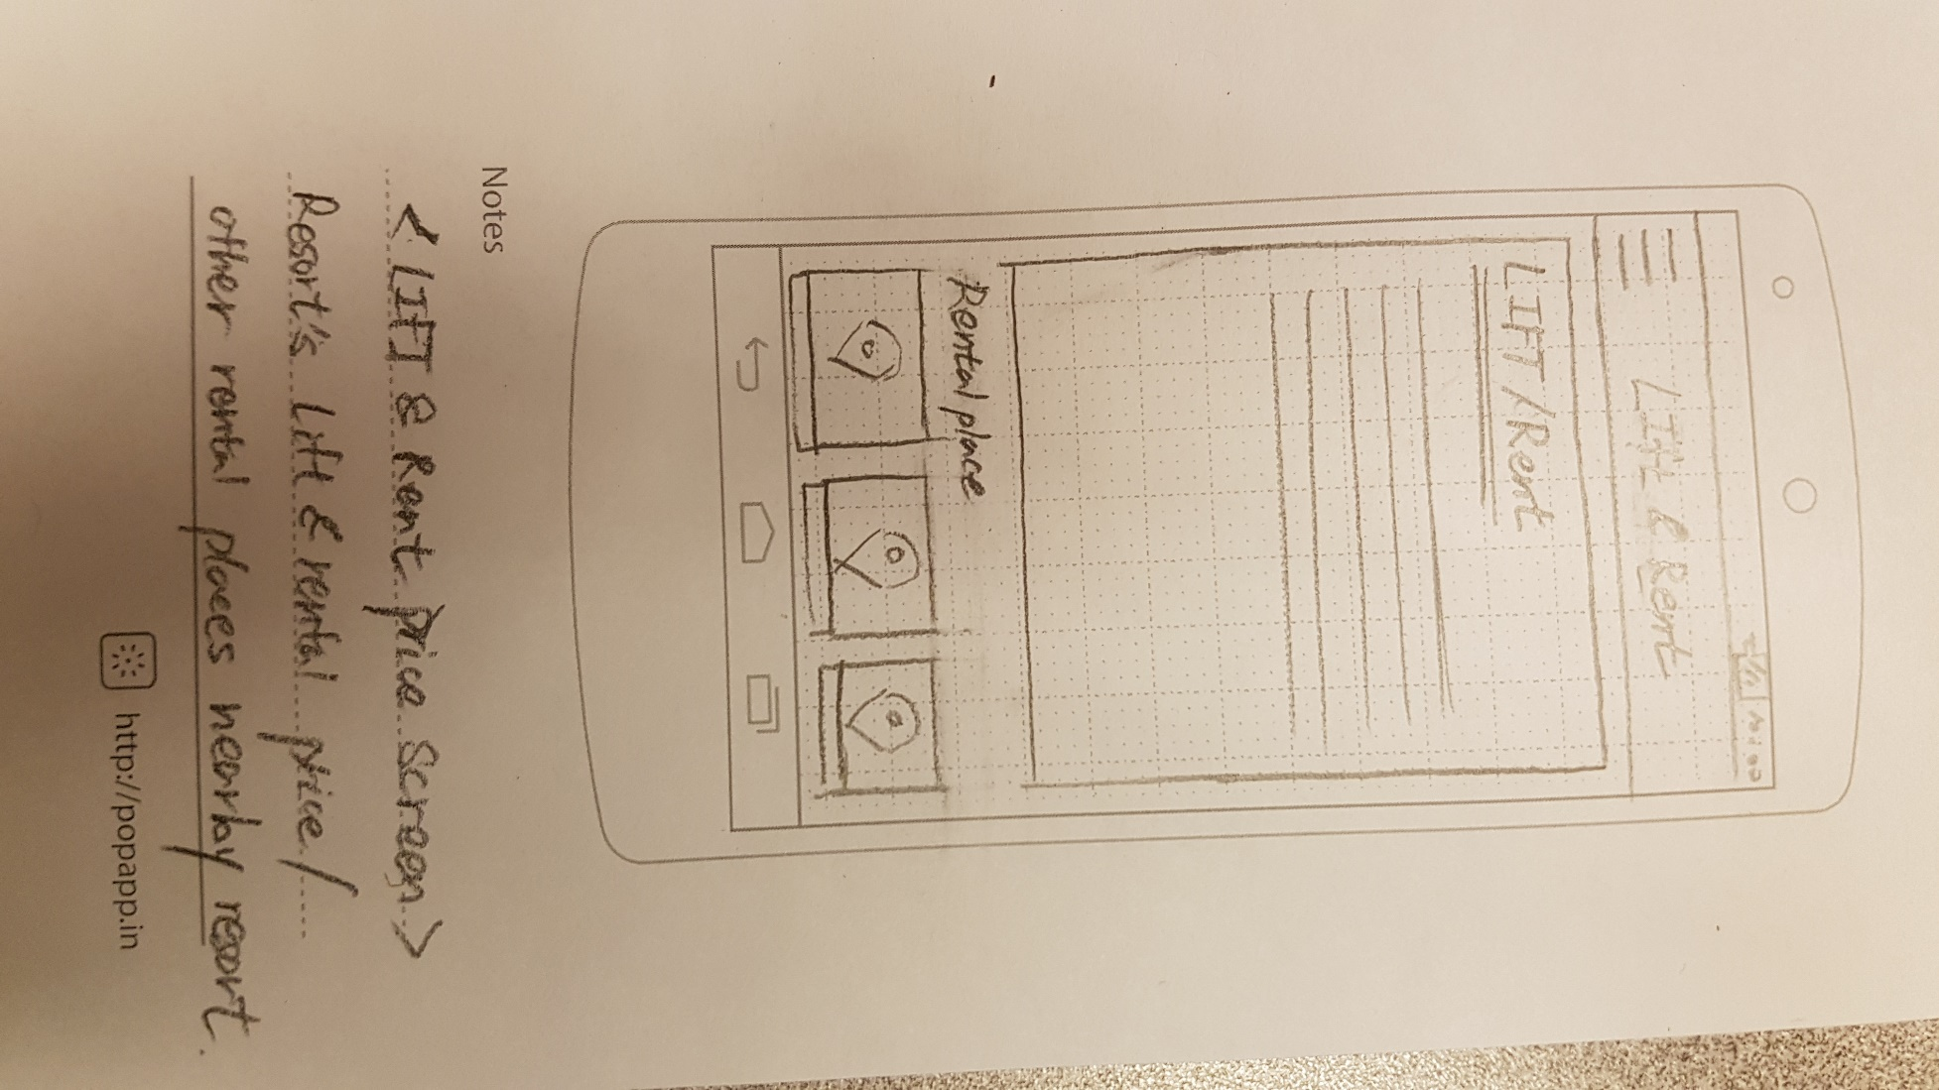

# Storyboard:

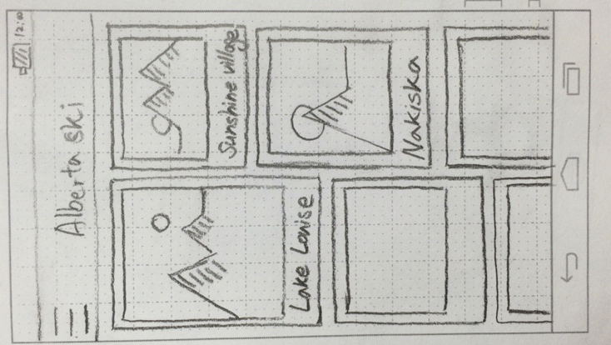Tom is a foreigner an expert at skiing and he wants to go to ski at this weekend. He wants to see information about ski hills in Alberta, so downloaded our app and started.

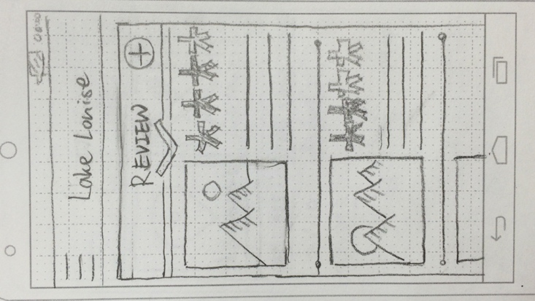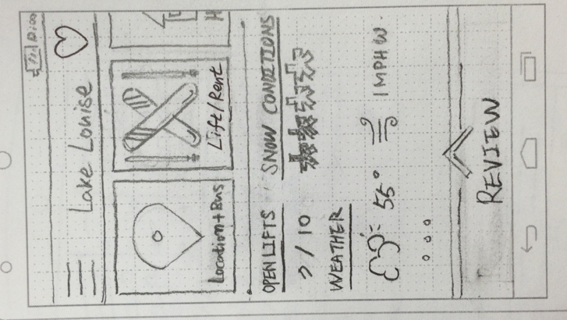He looks the main screen which lists ski hills in Alberta with pictures. He taps the Lake Louise button.

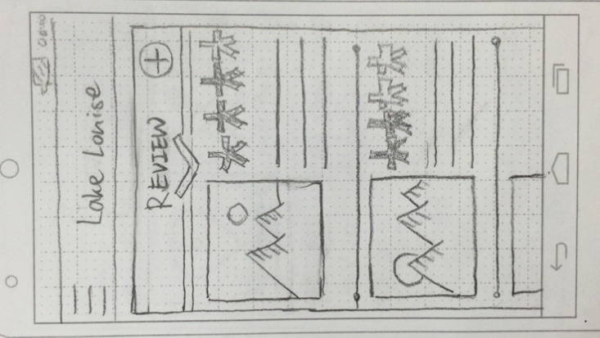After he got in, he looks at information whether it is open or not, snow conditions, specific weather info. He swipes up the ‘Review’ at the bottom of screen to see the reviews

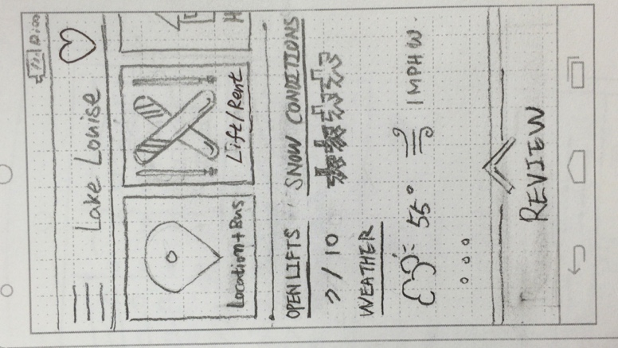He taps the one of the picture to see bigger image. After seeing overall information, he thinks Lake Louise is quite good to ski and he decide to see more in detail

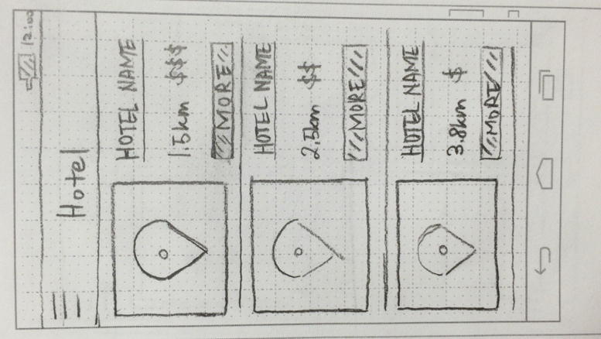He swipes the button lists (Location & Bus, Lift & Rent, Hotel, Resort overview) and taps the Hotel button because he is going to sleep there one night.

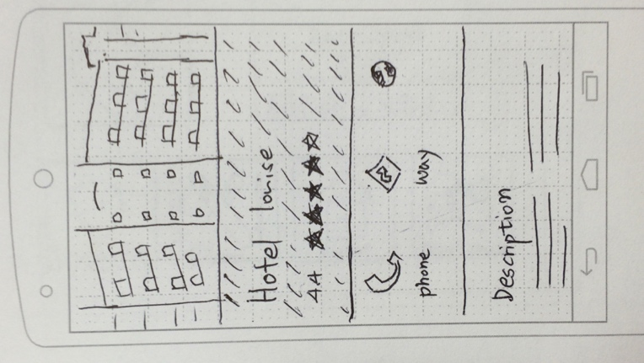The list of hotels with small map comes up which is ordered by distance from ski hill. He taps the ‘more’ button in the top of list.

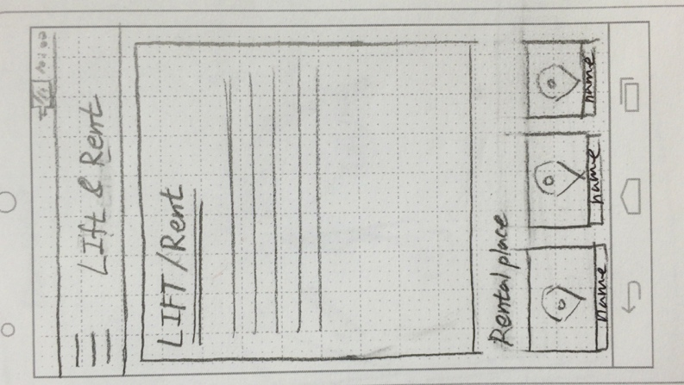The app converts to browser app which shows the hotels website. After deciding which hotel, he will reserve, he taps back to Lake Louise screen.

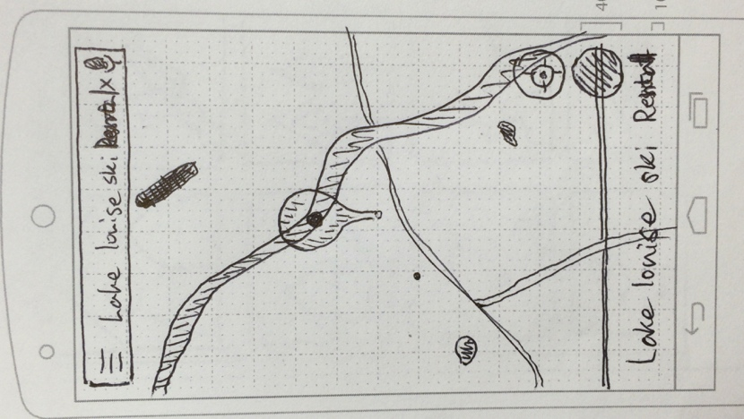He taps the Lift & Rent button to see the price of rental fee and lift. He thinks the gear rental price of ski resort is quite expensive, so he decided to rent at the other rental place near ski hill.

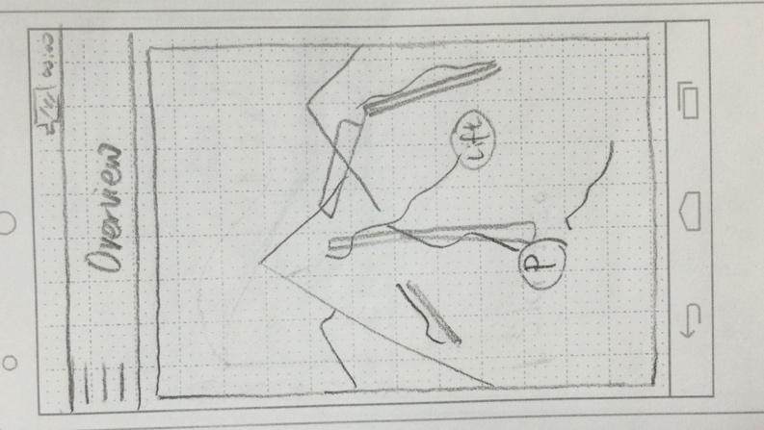He taps one of the rental places at the bottom of screen. App converts to google map which shows the location of the rental place.

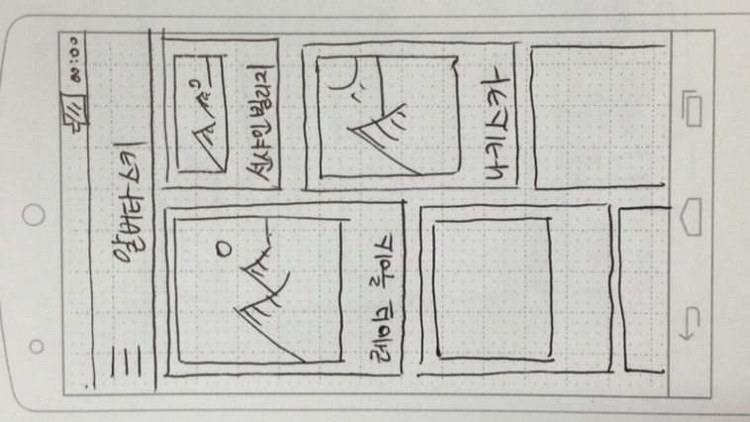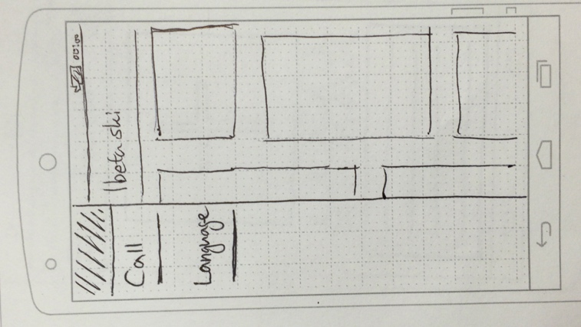Now he is curious about overview of the ski resort so he taps the Resort overview button. Screen shows him the whole overview map of the ski hill. He pinches to zoom in and out to see in detail.

He has a friend from South Korea, so he taps the button language button to change the language to show the app to his friend readable.

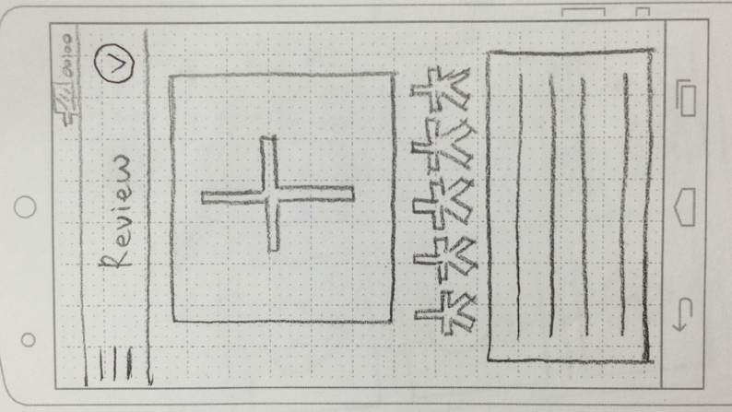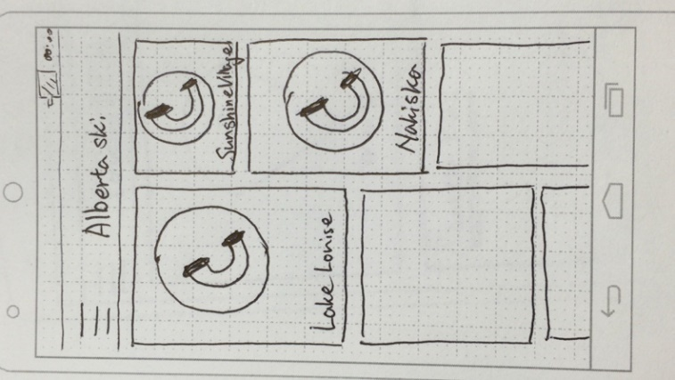Now he is in the Lake Louise ski hill, he stumbled over and he got hurt. He taps hamburger button at the left-top of screen and taps the call. The all list of ski hills in main screen changes to calling button, and he tap the button of Lake Louise. Snow patrol came and he is safe now.

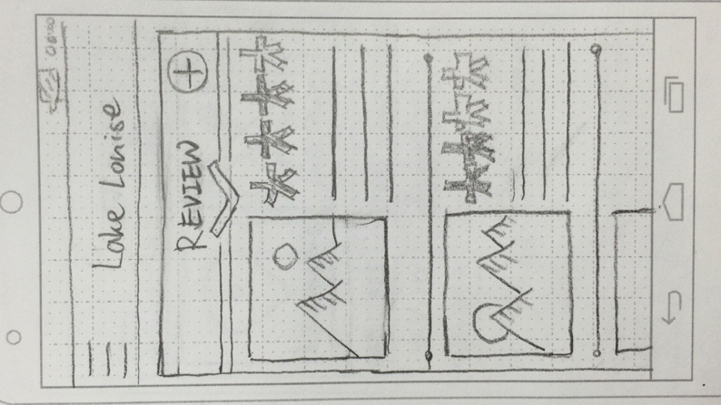After skiing, he wants to make a review, so he taps the add button in the Review screen. He puts photo, rates by swiping, types in content, and taps the check button at the right top of screen.

# Task descriptions

## Task 2:

**We have removed the fact that Sarah has become very familiar with our application because we feel that more can be said about the design of our app when someone who is unfamiliar with it uses it**

Sarah is an expert skier who skis internationally. Sarah has an extensive list of favorite resorts and needs to be able to compare the conditions between each of the resorts very quickly. The most important things for Sarah when planning a ski trip outside of her home country is the weather forecasts, the base snow pack compared to the snow base at the current date last year, and the availability of hotels within 10Km of the ski hill for easy access.

Sarah opens the app and navigates to her favorites page. From here, she scrolls through her list of favorite mountains. She selects all the mountains that have been snowed on in the last day and uses the compare feature to see the statistics of all the resorts compared side by side. She finds a resort that looks like a promising venture and navigates to its individual page. She then finds the accommodations tab and sees several links to hotels at and near the resort. After following the links, she finds that none of the hotels will do and returns from the resorts individual page to the comparison page. She visits the next hills individual page and follows its links to nearby hotels. Sarah finds a hotel that will do and closes the app.

|  |  |  |
| --- | --- | --- |
| **Task step** | **Knowledgeable?**  **Motivated?**  **Believable** | **Comments/suggested fixes** |
| Turn on the phone | * No problem |  |
| Open our application | * We must assume that the customer knows how to do this |  |
| Clicks on the menu tab on the top left of the page | * All Sarah knows about this button is that there are 3 lines in the top right corner. She does not know what this does. * Sarah needs to press something to take her to what she needs to do. She will begin pressing buttons. Due to our minimalistic design, she will eventually press the 3 lines at the top because there are very few buttons to press | We can make the buttons at the top flash for a first tie user to draw their attention |
| Sarah selects the mountain menu | * Sarah can figure out to do this because to get to this point, she must have figured out that tapping on things selects them * She is motivated to tap this button because it is in the shape of a mountain |  |
| Sarah observes the snow records for the past day | * Sarah can see the records for the past day and can understand them because she is an expert skier. * Since the recent snowfalls are displayed next to the name of the mountain in the mountain menu, this is very easy for her to see |  |
| Sarah clicks the compare button | * She does not know how to do this. To do this, you would tap and hold on a mountain selection tile and wait for the selection menu to appear. * She is not motivated to do this because she does not know that his is a feature and there is nothing indicating that this is a feature. | What we can do to fix this problem is either have a button that reads “compare”, have an icon at the top of the page that may indicate a comparison is possible, always have the comparison turned on, or give the user a tutorial |
| Sarah selects the resorts she would like to compare | * She knows how to do this because check boxes have appeared and they look like they can be tapped she will quickly figure out that they can be tapped. * She wants to compare them and this is a system used by other application and websites |  |
|  |  |  |

## Task 3:

Sira is a tourist from South Korea currently lives in hotel in Calgary for 3 days with her friends. She and her friends wants to go snowboarding in Banff but they don’t have any gears to do. They already choose the ski hill to go, so they want to check for the rental place. Sira and her friends are going to search in the app and change to Korean language to see more comfortable. They finds the information about ski gears rental in Calgary. And they pick the cheapest and nearest place to rent and gears. In the ski hill, one of her friend is hurt in the middle of the slope. So she finds ski hill information center number and ask for help. After a few minutes later, snow patrol come and get her friend to the nearest hospital.

|  |  |  |
| --- | --- | --- |
| **Task step** | **Knowledgeable?**  **Motivated?**  **Believable** | **Comments/suggested fixes** |
| Turn on the phone | No problem |  |
| Open our app | * Yes, she is used to use lots of apps * She is motivated to do this because she wants to search in the app * Yes | We assume that she can open the app and there is no compatibility issues. |
| Change language to Korean | * She has an experience in using apps, so she knows language change option will be in settings. Usually, setting buttons are inside of side menu, so she will tap the hamburger button * Yes, she is definitely motivated because she is Korean. | The language change button should be visible and as obvious as possible when opening the application.  There is nothing more difficult than trying to figure out how to change the current language to your spoken language if you have to decipher the language.  Maybe make the settings button a gear icon since the settings button for android is also a gear button. This helps facilitate positive transfer. |
| Find the information about rental | * She already decided which ski hill to go, so she taps the ski hill in the main screen. She can see the buttons which can be swiped, and there is Lift & Rental button. * She is motivated because she doesn’t have a gear. | The rental button is already visible the moment you access the resort overview. You do not need to scroll across the menu options to find this. |
| Compare the price of rental and distance from the resort. | * Yes, she can see not only the list of information about rental fee in ski resort but also other places to rent near the ski resort * She wants to save money from renting and go nearest rental place. | The prices of the rental items are visible under the actual item. This resembles the online shopping experience where you have items and the prices of the items located beneath it. This helps facilitate positive transfer. It is possible that she has done online shopping before so viewing rental items will be no different. |
| Ask help by emergency calling | * She will be little bit confused by finding the number to call, because it’s in the side menu * Yes, her friend is in real danger now, so she definitely needs this function | Solution: The emergency contact information is really important so it would be wise to include in the resort overview page so that it is easy to find.  The emergency contact information can be listed as a number under the resort name. |

## Task 4:

Benjamin is an exchange student from Norway and he is in intermediate level of skiing. He is expecting so much to ski in Banff, so he tries to find which ski hill is the best in Banff. He thinks important to check price of lifts, whether it is opened or not, accessibility, and ratings. He is planning to go for 3 days, so he also wants to find a good place to sleep near ski hill which provides kitchen. He will buy some foods that he’ll cook for breakfast, lunch and dinner, so he checks for grocery stores near the accommodation at the map.

|  |  |  |
| --- | --- | --- |
| **Task step** | **Knowledgeable?**  **Motivated?**  **Believable** | **Comments/suggested fixes** |
| Open our app | * Yes he is used to use lots of apps * It is not sure, because he may like to search in laptop * Yes | We assume that he can open the app and there is no compatibility issues. |
| Finding information about lifts | * Yes, he can tap a few of ski hills to compare. He can see the buttons which can be swiped, and there is Lift & Rental button. * Yes, he thinks it’s important to  check it and there are all of information about lifts in it | Information about lifts are accessed through a slide menu.  It is important to emphasize that the menu options can can rotated left to reveal more menu options. |
| Compare accessibility | * Yes , as same as before step, he can find the Location & Bus button in the screen. He can tap that button see the map in detail to check which ski hill is nearest from his university. * Yes, he really wants to go nearest place. He can compare all the distances from the university by using google map which is linked to our app |  |
| Look at the ratings and reviews | * Yes, Review tab is at the bottom of the screen in each ski hill screen, which is really easy to be found, so he can just swipe up to see the list of reviews and ratings. * Yes, as same as before he thinks it is quite important to know about other people’s evaluation. * Yes, he is absolutely written by people who have been to the ski hill by looking at photos. | The review button is directly under the resort name |
| Finding hotel to sleep | * Yes, he as same as before, he can tap the Hotel button, and compare the prices and distance from the ski hill. * Yes, he is going to ski for 3 days, so he definitely needs place to sleep. * Yes, in the Hotel screen, it shows the price of each hotel by the number of $, and distance by Km. And also has a ‘More’ button to link hotel’s website. |  |
| Finding grocery store near the hotel | * Yes, there is a map which is connected to google map, so he can easily check the nearest grocery store from hotel. * Yes, he has to cook lunch and dinner in hotel, so he has to know. * Yes, our app uses the google map, so it is believable. |  |

## Task 5:

Raza is a university student who is also a beginner. He heard from a friend that a resort named Panorama Mountain is an excellent place to go for beginners. He does not want to spend more money than what his budget allows and will stay for just the morning at the resort. He borrows the following skiing gear from a friend:

* Skis,
* Ski poles
* Goggles
* Helmet

To confirm that Panorama Mountain is a good place to go, he browses the list of resorts and searches for Panorama Mountain specifically. He looks at the overall rating of the resort. For more insight, he checks the user reviews of the resort. Next he must figure out if the resort can fit his budget so he checks the resort rentals. He looks at skiing boot sizes because his friend’s size does not fit him. After confirming that the resort has his boot size, he looks at the prices of the ski lifts. Finally, he looks at the location of the resort and the trail map to see if it is close to his home.

|  |  |  |
| --- | --- | --- |
| **Task step** | **Knowledgeable?**  **Motivated?**  **Believable** | **Comments/suggested fixes** |
| 1. Open the application | * Raza is a University student who probably used smart phone applications before. |  |
| 1. Looks for the list of resorts. | * Motivated to look for resorts list as he is searching for a specific resort. * It is believable that the first thing he does after opening the application is to look for his specific resort. | Raza is expected to look for some sort of resort listing if he cannot find the resort immediately. |
| 1. Select search bar. | * Since Raza has technology experience, he should know how to use a search function through previous experiences. * Strong motivation. | Since the list of resorts will be big, it is expected that Raza would not try to find the resort manually by going through the list and opt to use the search function instead.  The search function should be made as clear and obvious as possible. Perhaps include a form with ‘resort name’ pre-written on the text bar. |
| 1. Enter Panorama Mountain Resort | * Raza is an excellent typist. | Because Raza is young University student without injuries, text entry should not be a problem for him. Assuming that he has the selected the search function, there should be some sort of visual cue that leads him to type in the name of the Resort. |
| 1. Select resort ratings in overview menu | * He will be motivated because he wants to confirm that this resort is a good place to go to. * It is believable that he will select the resort ratings. * Since it is visible on the overview menu it should be clear (doesn’t have to slide through overview menu) | The ratings of the resort he resort can be accessed on overview page with a huge button.  If there are pictures of the resort on the overview than it is wise to put the review button right under the pictures; this setup is easy to understand. |
| 1. Select resort rentals in overview menu | * Raza is conscious of his budget. He will be motivated to search for the rentals page from the overview. * Since it is visible on the overview menu it should be clear (doesn’t have to slide through overview menu) | Raza wants to find what sort of rentals the resort has to offer so the button for this should be apparent in the resort overview page. |
| 1. Look for boots that fit him | * Since Raza wanted to borrow some equipment from his friend but the boots didn’t fit him, he will be motivated to look at boot sizes. | There should several boots and the sizes of the boots listed under the selected boot. |
| 1. Select ski lifts offerings in overview menu | * Raza wants to find ski lifts that are budget friendly. He will be motivated to look for ski lifts. | Raza wants to find something that fits his budget so he will check the availability of the skill lifts. It is located in the overview page so it will be easy to find. |
| 1. Look for the prices of ski lifts | * Raza is motivated to find something that fits in his budget. | The prices of the ski lifts should be right beside the ski lift. Seems obvious but this helps Raza do a quick scan of every ski lift. It is a lot easier than having to press a button for each ski lift and then viewing information about that ski lift manually for each one. |
| 1. Look at the overall map of the resort | * Raza is motivated to see where everything is located at the resort since it is his first time at the resort. | A map of the resort should be available somewhere on the main overview of the resort. |

## Task 6:

Patrick is an expert skier and snowboarder and wants to check information about a resort that he has not visited in a year. He wants to go skiing and already has most of the gear but must buy a new helmet. He plans to go sometime next weekend during Christmas with a group of friends.

He browses the list of resorts and searches for Sunshine village. He checks if the resort has any new hills to offer. He finds new hills and checks the difficulty of these hills. He checks the snow quality of the hills to see if it is freshly powdered which is the most preferable. He checks the resort shop to see if he can buy a helmet. He checks the resort rentals to see if it cheaper to rent a helmet several times. He checks the prices of the ski lifts tickets see if there are any holiday deals.

Patrick wants to make sure that the resort has everything for a weekend stay. He checks the food services of the resort. He checks the emergency services of the resort to see if there is an emergency number he can call. Finally, he checks if there are any nearby cabins to rent for his group of friends.

|  |  |  |
| --- | --- | --- |
| **Task step** | **Knowledgeable?**  **Motivated?**  **Believable** | **Comments/suggested fixes** |
| Open the application | * Ok |  |
| Look for lists of resorts | * Patrick is motivated to find his specific ski resort. * It is believable that the first thing he tries to do is attempt to find it. | Same as Raza. |
| Select search bar | * If he is unable to find his resort, he should be motivated to use the search bar. * It is believable that Raza can find the search bar. | Same as Raza. |
| Enter Sunshine village | * A visual cue should appear (keyboard) which motivates him to enter the name of his resort. | Patrick should be able to type this easily. |
| Look at snow quality of sunshine village | * The snow quality of the resort is listed on the resort overview. | This should be very easy to find, since it is located on the overview of the resort. |
| Select ski lift offerings in overview menu | * Patrick is an expert skier and is motivated to find this information. | The ski lift offerings are located clearly on the overview page. |
| Look at ski lift difficulty | * Has to find this by first looking through ski lift offerings. * Might be unmotivated to find this since it is not visible in the overview. It is also not visible in the ski lift offerings page. | You have to tap on the specific ski lift to view more information on it.  Solution:  It is probably a good idea to pull the difficulty out of the specific ski lift page and just put it beside the price. |
| Select resort services in overview menu | * Has to slide right until the option of resort services appears. Might not have knowledge of this. | Solution:  Could include everything in the top overview menu instead, but at the expense of having small buttons.  Maybe show an arrow or display instructions that you can slide through the menu, or show the extra menu options as a bubble the first time you open the application. |
| Look at what types of restaurants the resort has | * Might be unmotivated to find this because it is hidden until you access the resort services page. * Might not be aware that you can find restaurants under services. | Solution: Patrick might be interested in the reviews of the restaurant so under resort reviews, there could be another button that leads to restaurant reviews.  Restaurants can be put on the resort overview page  Drawback: There is more clutter on the overview page. |
| Look at the emergency services of the resort | * Same as above, might not be aware you can find emergency services under resort services | Solution: Since emergency services are important, a button for this page can be created on the overview page right under weather or ski lift offerings.  Another solution is to just list the emergency contact information of the resort instead of creating a specific button to page interaction. |
| Look at overall map | * Overall map of the resort is easy to find on the overview page. * It is believable he will find it. | A map of the resort should be available somewhere on the main overview of the resort. |

## Task 7:

Terry is a member of the ski patrol at his local ski resort. He has just gotten back to the ski patrols main base. He checks his phone and sees a notification reporting that there is an injured skier on a nearby run! Terry then accesses the report by taping on the notification. He can see on the report that the skier was skiing with 1 other person who has begun to ski to the nearest chair lift to find help. Included in the report is a description of this second skier. Terry goes to the lift near his base. Eventually the second skier shows up and reports the injury, Terry marks the report as in progress and travels to meet the injured person. When Terry returns to the ski patrol base, he marks the report as completed and closes the app.

|  |  |  |
| --- | --- | --- |
| **Task step** | **Knowledgeable?**  **Motivated?**  **Believable** | **Comments/suggested fixes** |
| Turn on the phone | * We need to assume that he is knowledgeable enough to do this as our app cannot help him * He is motivated to do this since he wants to use our app * Yes | There is not much that we can have our app do to help him turn on his phone |
| Open our application | * We assume that if a user can turn on the phone that they can open an application * He is motivated to do this because he wants to check if there are any injured skiers * Yes. If the ski patrol is doing nothing, it is believable that they would check their phones | If we wanted to help Terry open the application, we could make it so that the application opens when the phone is turned on, however, we believe that overall, this feature would be detrimental to the success of our application. |
| Tap the notifications icon | * Terry works for the ski patrol, since he knows what to look for to help skiers, it is believable that he would know how to check the menu * Terry is motivated to check this because there will be a red dot over the button that will take a user to the notifications tab. This light will inform Terry that there is a new notification to check. | It might be helpful to allow each user to manually set what page the application opens to on default. This would allow Terry to never miss a notification. |
| Read the notifications | * The notifications will be in either English or Korean. So long as Terry speaks one of these, he is good. | It would be helpful to use the google language API to allow our app to be translated and allow more users |
| Mark the notification as in progress | * Terry may not know to do this depending on how long he has been using the application * Terry is motivated to do this as he wants to let his ski patrol fellows know that he has this problem | We need to have the button large enough so that people will know that they can mark a notification as in progress and a confirmation check so that a person dos not accidently press it |
| Mark the notification as complete | * Terry may believe that once he marks the notification as in progress that there is nothing ore that he needs to do with the app. * Terry is now doing his ski patrol job; he will not be motivated to do this because he is working | After a user marks a job as in progress, they can get a reminder to mark the notification as complete, letting them know that they can and should do this. |
| Close the app | * No problems |  |

## Task 8:

Sam is a manager at a hotel near a ski resort. Sam’s hotel is having a weekend special on rooms for 4 or more people and needs to advertise this. Sam has advertised in other locations but wants to do more so he opens our app and finds the ski resort hear him. Sam then navigates over to the accommodations page, finds his hotel in the list, opens the page for his hotel, and posts an image describing the weekend deal with all important information. Terry then closes the app.

|  |  |  |
| --- | --- | --- |
| **Task step** | **Knowledgeable?**  **Motivated?**  **Believable** | **Comments/suggested fixes** |
| Turn on the phone | * No problem |  |
| Open our application | * We must assume that the customer knows how to do this |  |
| Tap on the side icon on the right | * I assume that this user has never used this app before. Therefore, he will not be knowledgeable about this * He will be motivated to press the button because he will be able to see that he is not where he needs to be so he will start pressing buttons. Due to our low button volume design philosophy, he will surly press this button | We may have to design a tutorial for first time users. Or we can make the button flash on first time start up to draw attention and encourage people to press the button. |
| Tap the icon for hotels | * Yes. He has taped to open the menu so he knows to tap to select things * Yes. He is trying to work for a hotel and this button is represented by the word hotel * Yes |  |
| Scroll the menu to find his hotel in the list | * Yes, we have designed the menu so that there is one hotel photo off the page. Seeing this, Sam will know that he can scroll through the page to find more hotels. * Yes. Again, Sam needs to find his hotel in the list, he can see that he can scroll, so he will. | It might help some users who are unfamiliar with scrolling if there is an arrow, or a tutorial on how to swipe. |
| Identify the hotel | * Since he knows what his hotel looks like, the name of the hotel, and the address, it is reasonable to assume that Sam will be able to identify his hotel in the list. * Same motivation as before | It might help users who are searching for a specific hotel if there is a search or a filter option |
| Tap the picture of the hotel | * Problem, up until this point, Sam has only tapped menu icons, not photos. It is possible that he does not know that he can tap a photograph. However, because of the minimalistic design, there is very little that he can tap and therefore will probably get there eventually. * He has the motivation to do this because he needs to post the ad. He has taped things before, so it is possible that he will begin tapping things on the item representing his hotel to get more information. | It might be beneficial to have a button beside the hotel saying “Go To” or perhaps an overlay on the hotel photos saying “tap”. |
| Scroll down the page to the news area | * Sam has had to scroll in the past to find more information about something in the app. * The motivation behind this is that he can see that the description of the hotel carries on below the bottom of the page. This combined with the previous knowledge of scrolling means he will be motivated to do this |  |
| Taps the button saying “ADD NEWS” | * Sam can read English. Therefore, same will know that this will allow him to add news to the page. * This is what Sam came here to do! Of course, he is motivated! | It might not be a good idea to allow everybody to be posting news, but it would also allow more news to be posted. |
| Find the photo of the advertisement on his phone | * At this point, the app will open to Sam’s photos. Knowing what he does from this point, Sam knows how to find the photo | It might be beneficial to give the user the ability to enter their file directory to find the photo that they are looking from, or to access it from their google drive. This may be a confusing complication however. |
| Select the photo | * To do this he taps on the photo. That is how he has been selecting things, so he knows how to do this. To finish selecting, he taps the “select” button in the top right of the screen | This is a very common feature on other applications on android devices. |
| Close the application | * After Sam selects the photo, it will be automatically uploaded to the server that Sam will be able to see via a progress bar. Then it will appear at the top of the new section by his hotel. Sam has now completed his task. * Sam watches the progress bar and sees that the photograph has been uploaded. He now knows that his task is complete | It may be beneficial to give a confirmation screen between the steps to prevent mistakes |